**Economic Indicators in General Aviation**

The general aviation industry goes through many ups and downs over the years. It can be a roller coaster of needs where some years shipments are high and hard to keep up with and other years manufacturers cannot sell all the aircraft they built. This project looked into these trends for both jet and turboprop aircraft to see if certain economic indicators can predict when aircraft shipments will rise or fall. Having an idea of where the future is headed a couple years in advance can greatly benefit general aviation aircraft manufactures. The decisions for how many aircraft to build typically occur a year or more in advance of when said aircraft would actually sell. Making too many aircraft is a loss in profit because it drives down the sale price and it costs money to hold onto aircraft after they are built. Using economic data gathered from the Federal Reserve Economic Data (FRED) source, I found relationships that aligned with the general aviation aircraft shipment numbers. For most economic indicators, this means that as one increases shipment numbers also increase. Using that information, I built predictive models to get a prediction of where the number of aircraft shipments are headed in the next couple years. The first few models I built did not fit the data well. I then took a more traditional approach, using only the historical shipment information to predict the future. The outcome here was more successful. Although the best model used no economic data, that does not mean that there are no economic indicators out there that can infer on the general aviation industry. I found strong relationships with metrics like personal income and unemployment rates that aligned with the industry, and there are many more metrics available to test. This project can pave the way for a deeper analysis into more economic data and trends.

**Introduction**

***Background***

What drives the general aviation industry? The consumers of these smaller aircraft tend to vary and with that, the needs of the industry as a whole can change on a whim. There are a mix of individual owners, businesses, training purposes, and special missions that make up the end customer. In addition to the diverse consumers, the market can be unknown at times. Following events such as the recent pandemic, it has become more important to gather an insight into what the future may look like. Having this could help make business decisions in regard to how many aircraft to build based on the predicted need. This will in turn save the business both time and money.

***Problem Statement***

The problem of not knowing how the industry will perform has the impact of decreased profits for a general aviation business, so a good starting point would be to look for economic indicators that help predict aircraft shipments. This project will specifically look at economic indicators within the United States. The US makes up a large portion of the general aviation market so focusing on economic data from this country could be a driver. If it is not, then that itself is beneficial information for understanding the industry.

***Scope***

This is a solo project with a 12 week timeline to work through the data and build a prediction. Due to the people and time limitations, only a select number of economic indicators will be evaluated against jet and turboprop shipments.

**Methods**

***Data***

The data for this project has been gathered from the General Aviation Manufacturers Association (GAMA) and the Federal Reserve Economic Data (FRED). GAMA has quarterly aircraft shipment data that goes back to the 1970’s and FRED provides a large amount of economic data at different intervals to choose from.

*Data Dictionary*

* Date: Year-Month-Day identifying first day of the quarter
* Cat: Market category of the aircraft to depict the size of the aircraft
* MFR: Manufacturer of the aircraft
* Model: The specific model of the aircraft
* Year: Shipment year
* Quarter: Shipment quarter
* Shipments: Number of shipments
* Class: Identifies if the aircraft is a jet or turboprop
* GDP: US GDP in billions of dollars, seasonally adjusted annual rate
* CPI: Consumer Price Index – total all items for the US, growth rate previous period, not seasonally adjusted
* PCE: Personal Consumption Expenditures in billions of dollars, seasonally adjusted annual rate
* DEBT: Total Public Debt US in millions of dollars, not seasonally adjusted
* NROU: Noncyclical Rate of Unemployment
* WTI: Global price of WTI Crude; US dollars per barrel
* BRENT: Global price of Brent Crude; US dollars per barrel
* PI: Personal Income per Capita

***Data Preparation***

The data for this project required very little preparation to get it ready for modeling. The economic data was all downloaded from FRED using CSVs and had no errors. The GAMA data was pulled from their many PDFs that they have posted throughout the years. Working with primarily numerical data made it easy to confirm that the data was in good shape. There were no nulls or missing inputs that needed to be accounted for. One area that raised concern was the number of turboprop shipments before 1990.

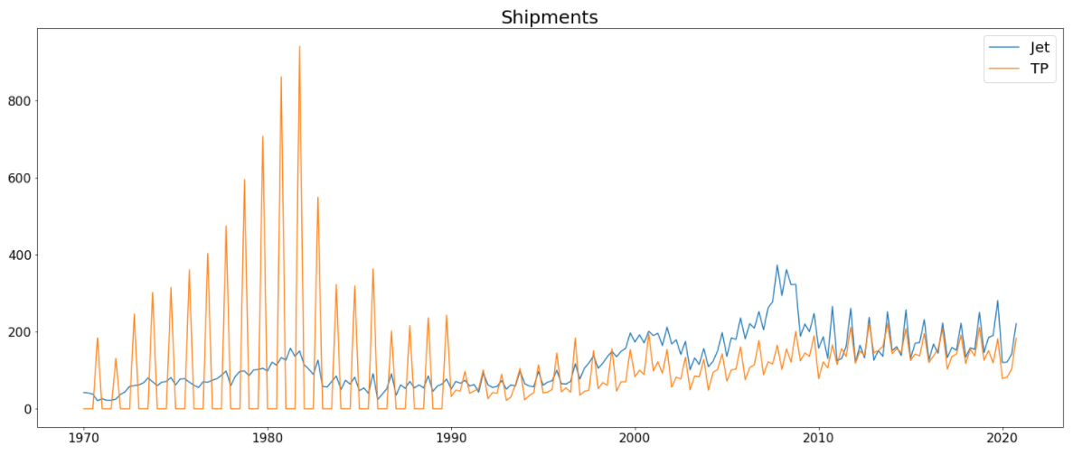

**Figure 1.** *Aircraft shipment numbers from 1970 – 2020 for general aviation jet and turboprop aircraft.*

As seen in Figure 1, the turboprop shipment numbers are extremely high prior to 1990. This data is accurate but it is not an accurate representation of where those shipment numbers are at in the market today. I chose to cut the shipment data in 1990 so the range used would be 1990 – 2020. I decided to do this because I did not want the high shipment numbers to influence the models or predictions. I also had trouble finding each economic variable back to 1970 so trimming the years allowed me to include more economic metrics.

***Feature Selection***

In order to determine if the economic variables in the data have significance with the target variable of shipments, feature selection needs to be done. All the variables in the final dataset are numerical. To test for significance I used Pearson’s correlation. I checked the strength of the relationships of each economic feature with shipments and checked for multicollinearity within the economic features.

**Figure 2.** Pearson’s Correlation Heat Map.

Figure 2 uses a heat map to visually show the strength of the relationships between all the variables in the dataset. The strongest relationships shipments had with economic features were with NROU and PI. NROU had a -0.71 correlation indicating a somewhat strong negative relationship. PI had a positive relationship with a 0.70 correlation. Both of these features were chosen to be kept in the model. DEBT and CPI had the weakest relationships with shipments. DEBT had a correlation of 0.55 while CPI had a correlation of -.32. Due to these weaker relationships both of those variables were excluded from the model. The rest of the features had moderate relationships with the data, these numbers can be seen in Figure 2. In an effort to further check for significance, I ran an Ordinary Least Squares (OLS) model to see which features were considered significant with shipments. The model listed NROU, PI, WTI, and BRENT as the only features with significance. I could not include both WIT and BRENT in the final model though as these variables are highly correlated with each other. Figure 2 shows that WTI has a stronger relationship than BRENT so moving forward I went with NROU, PI, and WTI as the final features to help predict shipments.

***Models***

The target variable of shipments is numerical and so I chose a couple different regression models to perform. I opted to do a linear regression, random forest, and a univariate ARIMA forecasting model. I ran many variations of each type of model to get to the best version of each. This would allow me to compare all three to ultimately chose the best model for the data. The initial runs saw some issues, I mostly experienced problems with overfitting. To fix that, more time was spent in feature selection to account for multicollinearity and hyperparameter tuning was done to improve the models.

**Results**

The overall results from each of the models were not exactly as expected.

***Linear Regression***

The first model I wanted to do was an OLS regression. A simple linear regression can provide a good baseline to use for comparing it to other models. See Figure 3 below for the results of the linear regression.

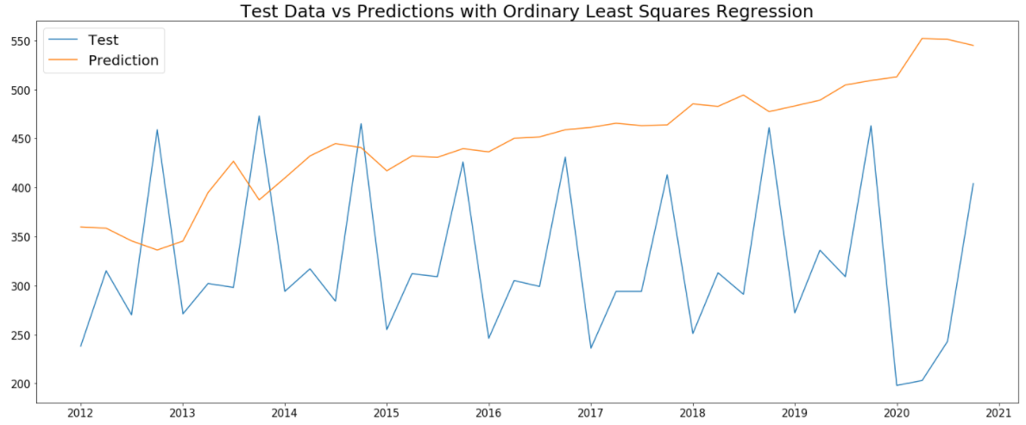

**Figure 3.** *OLS Regression Model Predictions from 2012 – 2020.*

As shown in Figure 3, the predictions are headed in an upward trend. This is not the trend of the actual data from 2012 to 2020. Visually, the model does not look to be fitting the data very well.

**Table 1.** *OLS Regression Evaluation Metrics.*

|  |  |  |
| --- | --- | --- |
| MAE | MSE | R2 |
| 140.3968 | 26296.3255 | -3.3118 |

The evaluation metrics show how poorly the model has fit the data. The mean absolute error (MAE) and mean squared error (MSE) are fairly large values. Additionally, the R-Squared metric is in the negatives which indicates the predictions aren’t following the correct trend of the data.

***Random Forest***

The random forest model was able to better fit the data than the linear regression, but not by much.

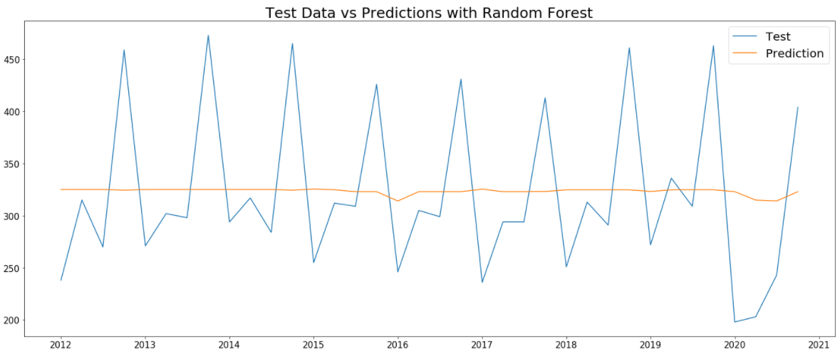

**Figure 4.** *Random Forest Regression model predictions from 2012 – 2020.*

The random forest predictions take a much more understated approach. The prediction is almost a perfectly straight line around the median number of shipments. It is not understanding the variation between the quarters. Especially the high volume of shipments that occur in the final quarter of each year.

**Table 2.** *Random Forest Regression Evaluation Metrics.*

|  |  |  |
| --- | --- | --- |
| MAE | MSE | R2 |
| 63.2322 | 5982.3044 | 0.0203 |

The evaluation metrics for the random forest look better than the linear regression. Both the MAE and MSE have lowered some. The R-Squared value is also no longer negative. With that, an R-Squared value that low is not good, therefore this model still is not a good fit of the data.

***ARIMA Forecast***

In an effort to get a better prediction of this data, I took a more traditional statistic approach. I used a univariate ARIMA forecast to see how quality of predictions I can get using just the shipment data history.

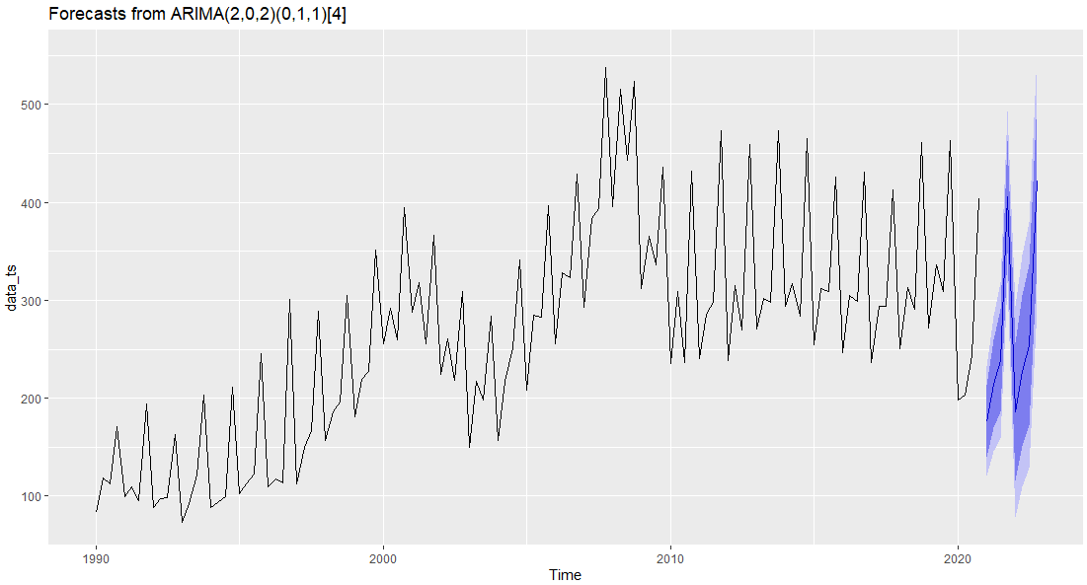

**Figure 5.** *Univariate ARIMA Forecast for 2021 – 2022.*

Looking at the visual, the predictions in Figure 5 looks to better represent the trend of the data than each set of predictions from the machine learning model. The peaks at the end of the year are identified and it is following a more accurate trend.

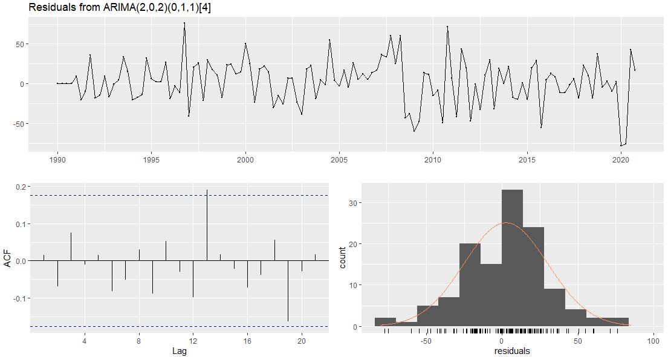

**Figure 6.** Univariate *ARIMA Residuals*.

The residuals from the ARIMA model look good. They look like white noise, there is no trend or seasonality within the residuals. The ACF plot also looks as it should, everything is mostly within the boundaries. Lastly, the histogram, which could be better, is still showing a normal distribution. The Ljung-Box test gave the model a p-value of 0.4208. This also indicates that the residuals are independent which is good for the model.

**Conclusion**

After looking at all of the models, the ARIMA outperformed each of the machine learning models. This was an interesting find considering I was looking for influential economic indicators and ended up with the best model using none of those indicators. I do not think this means there are no economic indicators that can be used to help predict the direction of the general aviation industry. There are a vast amount of possible economic metrics to chose from, I may have picked the wrong ones, or a poor combination of metrics. Additionally, given more time and resources, the models performed here have room for improvements. I would be hesitant moving forward with only the ARIMA model because even though those predictions were the best, there are some faults there. Since ARIMA assumes future trends will mimic the past, the drop in shipments from COVID-19 in 2020 were repeated in the 2021-2022 predictions. The current state of the market is showing to be quite different. The trend is actually up to 2019 levels, and almost surpassing them. With that being said, the project was still able to provide good insight into how economic indicators may, or may not in this case, play a role in understanding the general aviation industry.

**Acknowledgements**

I would like to acknowledge and thank Bellevue University, all of the professors I have had so far in this program, and all the people that provide open source information on the internet. The knowledge, insights, and education that has been provided have helped shape how I can become a data scientist and complete in depth projects with beneficial and accurate results.

**References**

Federal Reserve Bank of St. Louis. (n.d.). *Federal Reserve Economic Data: Fred: St. Louis Fed*. FRED. Retrieved January 16, 2022, from https://fred.stlouisfed.org/

*Quarterly Shipments and Billings*. GAMA. (n.d.). Retrieved January 16, 2022, from https://gama.aero/